### 

### Semester One Examination, 2019

### Question/Answer booklet

# Yr 12 SPECIALIST

**UNIT 3**

## Section Two:

## Calculator-assumed

|  |
| --- |
|  |

Your Name

Your Teacher’s Name

## Time allowed for this section

Reading time before commencing work: ten minutes

Working time: one hundred minutes

## Materials required/recommended for this section

***To be provided by the supervisor***

This Question/Answer booklet

Formula sheet (retained from Section One)

***To be provided by the candidate***

Standard items: pens (blue/black preferred), pencils (including coloured), sharpener, correction fluid/tape, eraser, ruler, highlighters

Special items: drawing instruments, templates, notes on two unfolded sheets of A4 paper, and up to three calculators approved for use in this examination

## Important note to candidates

No other items may be taken into the examination room. It is **your** responsibility to ensure that you do not have any unauthorised material. If you have any unauthorised material with you, hand it to the supervisor **before** reading any further.

**Structure of this paper**

|  |  |  |  |  |  |
| --- | --- | --- | --- | --- | --- |
| Section | Number of questions available | Number of questions to be answered | Working time (minutes) | Marks available | Percentage of examination |
| Section One:  Calculator-free | 7 | 7 | 50 | 49 | 34.5 |
| Section Two:  Calculator-assumed | 13 | 13 | 100 | 93 | 65.5 |
|  |  |  |  | **Total** | 100 |

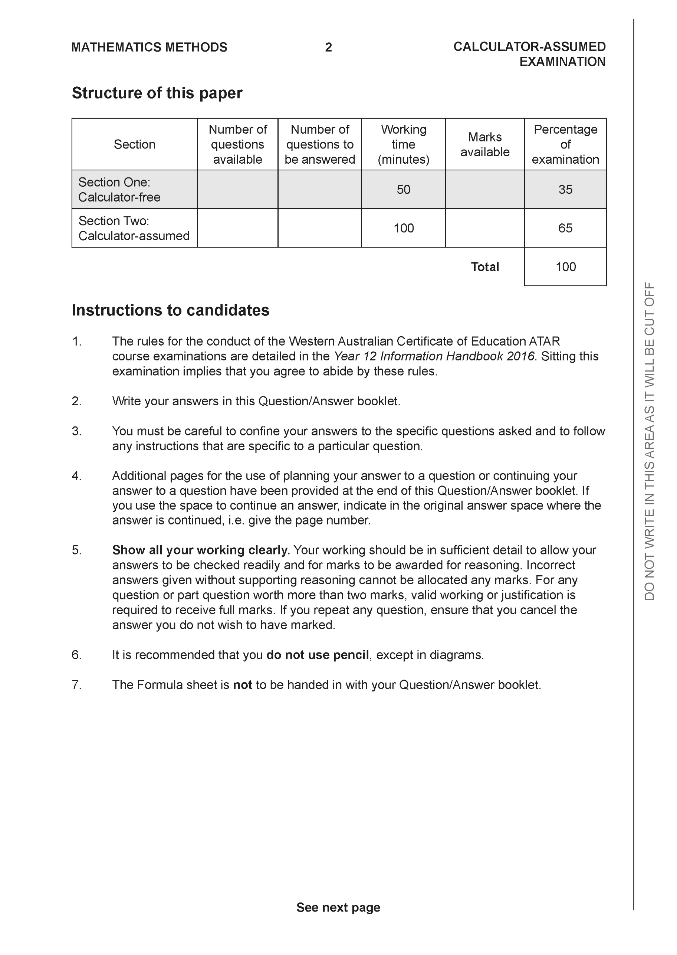

**Section Two: Calculator-assumed (93 Marks)**

This section has **13** questions. Answer **all** questions. Write your answers in the spaces provided.

Spare pages are included at the end of this booklet. They can be used for planning your responses and/or as additional space if required to continue an answer.

● Planning: If you use the spare pages for planning, indicate this clearly at the top of the page.

● Continuing an answer: If you need to use the space to continue an answer, indicate in the original answer space where the answer is continued, i.e. give the page number. Fill in the number of the question that you are continuing to answer at the top of the page.

Working time: 100 minutes.

**Question 8 (6 marks)**

1. Sketch the following region in the complex plane,  (3 marks)

|  |
| --- |
| **Solution** |
|  |
| **Specific behaviours** |
| 🗸 plots points  🗸 draws perpendicular bisector  🗸 shades correct region and includes line |

1. Determine the cartesian equation of  (3 marks)

|  |
| --- |
| **Solution** |
| Midpoint |
| **Specific behaviours** |
| 🗸 uses midpoint  🗸 uses perpendicular gradient  🗸 states cartesian gradient  OR  🗸uses subs z=x+iy  🗸determines magnitude of both sides  🗸squares both sides and simplifies to find cartesian rule |

**Question 9 (6 marks)**

1. Given that , where  is a constant, is only true for , determine the value of .

(3 marks)

|  |
| --- |
| **Solution** |
| At x=1 -2=-|1+a| a=-3 or 1  At x=6 -3=-|6+a| a=-3 or -9  Common value a=-3 |
| **Specific behaviours** |
| 🗸 equates y values at x=1  🗸 equates y values at x=6  🗸 determines common value of a |

1. Given that , where  are constants, is only true for  , determine the values of . (3 marks)

|  |
| --- |
| **Solution** |
|  |
| **Specific behaviours** |
| 🗸 determines a  🗸 determines b  🗸 determines c |

**Question 10 (8 marks)**

Consider the locus of points on  in the complex plane.

1. Sketch this locus below. (2 marks)

|  |
| --- |
| **Solution** |
|  |
| **Specific behaviours** |
| 🗸 circle shape  🗸 correct centre and radius |

1. Determine the minimum principal on this locus. (3 marks)

|  |
| --- |
| **Solution** |
|  |
| **Specific behaviours** |
| 🗸 determines argument of centre  🗸 adds argument with triangle of tangent  🗸 states the principal argument(does not need to be rounded) |

1. Determine the maximum value of  on this locus. (3 marks)

|  |
| --- |
| **Solution** |
|  |
| **Specific behaviours** |
| 🗸 recognizes distance from -6i  🗸 determines distance to centre  🗸 determines maximum distance |

**Question 11 (5 marks)**

Show that the line  is parallel to the plane  and determine its distance from the plane.

|  |
| --- |
| **Solution** |
| |  |  | | --- | --- | |  |  | |
| **Specific behaviours** |
| 🗸 identifies vector parallel to line  🗸 shows that normal perpendicular to line  🗸 uses a normal line through a point on line  🗸solves for where line meets the plane  🗸determines distance from plane.  OR  🗸determines point on plane  🗸determines vector between point on plane and point on line  🗸determines unit normal vector  🗸uses dot product to determine distance  🗸determines distance |

**Question 12 (5 marks)**

Let , where , consider the sum .

1. Sketch a diagram of this sum in the complex plane. (2 marks)

|  |
| --- |
| **Solution** |
|  |
| **Specific behaviours** |
| 🗸 denotes angles and lengths of arrows  🗸 adds numbers as vectors |

1. Obtain an expression for the  in terms of . (3 marks)

|  |
| --- |
| **Solution** |
|  |
| **Specific behaviours** |
| 🗸 uses cosine rule  🗸 determines opposite angle to modulus  🗸 obtains correct expression |

**Question 13 (6 marks)**

1. Determine a vector that is perpendicular to both and  and has a magnitude of .(Do not simplify) (3 marks)

|  |
| --- |
| **Solution** |
| |  |  | | --- | --- | |  |  | |
| **Specific behaviours** |
| 🗸 uses cross product  🗸 uses unit vector  🗸 uses magnitudes of all vectors to determine correct vector |

1. Let  and  where  is a real constant. In terms of , determine an expression for the angle between . (3 marks)

|  |
| --- |
| **Solution** |
|  |
| **Specific behaviours** |
| 🗸 uses dot product  🗸 determines magnitude of both vectors  🗸 determine an inverse cosine expression |

**Question 14 (10 marks)**

Consider a plane defined by .

1. Determine a normal vector to this plane. (1 mark)

|  |
| --- |
| **Solution** |
|  |
| **Specific behaviours** |
| 🗸 uses cross product |

1. Determine the cartesian equation of this plane. (2 marks)

|  |
| --- |
| **Solution** |
|  |
| **Specific behaviours** |
| 🗸 uses dot products with normal  🗸 determines a cartesian equation |

1. Show how to determine the distance of point  from the plane above **using** scalar dot product and the normal vector. (4 marks)

|  |
| --- |
| **Solution** |
| |  |  | | --- | --- | |  |  | |
| **Specific behaviours** |
| 🗸 uses a normal vector through point  🗸 solves for where line meets plane using dot product  🗸 uses two points  🗸 determines distance  OR  🗸determines a point on plane  🗸determines vector from P to this point  🗸determines unit normal  🗸dot product between these two vectors |

1. Consider a general plane , where  are constants. Show that the distance of point  from this plane is given by the expression  (3 marks)

|  |
| --- |
| **Solution** |
| Point on plane x=0=y |
| **Specific behaviours** |
| 🗸 determines a point on plane  🗸 separation vector between this point and Q  🗸 uses dot product with unit normal |

**Question 15 (8 marks)**

In deep space an astronaut is space walking outside a stationary space station. At time  seconds the astronaut is positioned at  metres relative to the space station and is moving with a velocity of  metres per second. A rogue satellite is observed to be at position at time  with a velocity of metres per second relative to the space station.

The satellite emits radiation and if the astronaut comes within 70 metres of the satellite the dosage will be harmful.

1. Determine the distance between the astronaut and satellite at  seconds.

(3 marks)

|  |
| --- |
| **Solution** |
| |  |  | | --- | --- | |  |  | |
| **Specific behaviours** |
| 🗸 determines position of astronaut at t=3  🗸 determines position of satellite at t=3  🗸 determines distance apart |

1. Determine if the astronaut is in danger and if so for how long in seconds, 2dp.

(Justify your answer). (5 marks)

|  |
| --- |
| **Solution** |
| |  |  | | --- | --- | |  | ((abs(10*x+11))^2+(abs(9*x+54))^2+(abs(4*x-16))^2)^0.5 | |
| The first 1.23 seconds the astronaut is in danger. |
| **Specific behaviours** |
| 🗸 determines position of astronaut at t seconds  🗸 determines position of satellite at t seconds  🗸 determines distance apart in terms of t  🗸 solves for time when distance apart equals 70 metres  🗸determines time that astronaut is in danger |

**Question 16 (4 marks)**

Consider the two spheres  and .

Determine whether there are any common points on both spheres. Justify your answer.

|  |
| --- |
| **Solution** |
| Centre (-4,1,-1)    Only one common point as distance between centres equals sum of radii |
| **Specific behaviours** |
| 🗸 determines centre of second sphere  🗸 determines radius of second sphere  🗸 determines distance between centres  🗸 shows that spheres touch at only one point |

**Question 17 (4 marks)**

Show **using vector cross** **product**, how to determine the distance of point  from the line  .

|  |
| --- |
| **Solution** |
| |  |  | | --- | --- | |  |  | |
| **Specific behaviours** |
| 🗸 de3termines vector from point on line to pt A  🗸 uses cross product with vector parallel to line  🗸 uses unit vector  🗸 determines approx distance from pt A to line using cross product |

**Question 18 (9 marks)**

Consider the line  and the sphere  where  is a constant.

Determine the values of , to two decimal places, for each of the following scenarios:

(Justify your answers)

1. the line does not meet the sphere at all.
2. the line meets the sphere at two points.
3. the line is a tangent to the sphere.

|  |
| --- |
| **Solution** |
| 1. alpha less than 12.34 but greater than zero 2. alpha greater than 12.34 3. alpha equal to 12.34 |
| **Specific behaviours** |
| 🗸 subs line into vector eqn of sphere  🗸determines magnitude of left hand side  🗸 derives a quadratic equation for  🗸 determines an expression for det in terms of  🗸 equates det to zero and solves  🗸only accepts positive values  🗸determines values for not meeting  🗸 determines values for meeting at two points  🗸 determines value for scenario of tangent |

**Question 19 (13 marks)**

Consider a prism where opposite sides are congruent parallelograms(parallelepiped) with coordinates .

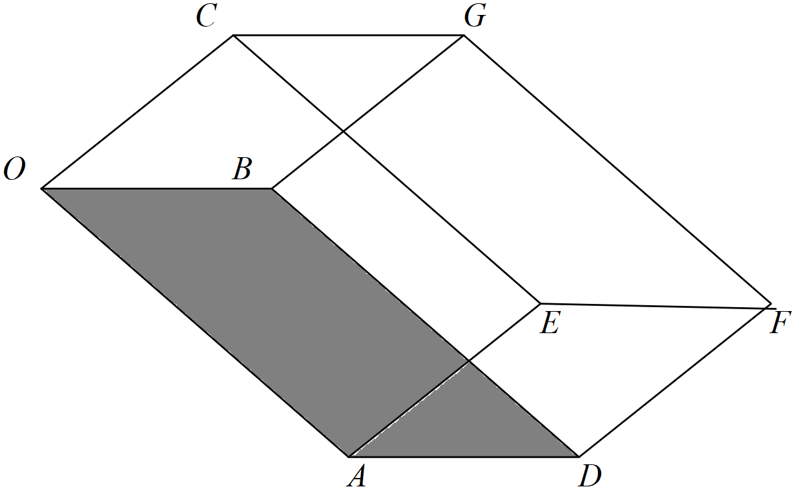

1. Determine a unit normal vector to the base . (3 marks)

|  |
| --- |
| **Solution** |
|  |
| **Specific behaviours** |
| 🗸 determines two vectors in base plane  🗸 uses cross product  🗸 determines unit vector |

1. Using this unit normal, determine the distance between the sides .

(Hint-use vector ) (3 marks)

|  |
| --- |
| **Solution** |
|  |
| **Specific behaviours** |
| 🗸 determines OC vector  🗸 uses dot product  🗸 determines distance |

1. Show using cross product how to determine the area of the base .

(2 marks)

|  |
| --- |
| **Solution** |
|  |
| **Specific behaviours** |
| 🗸 cross product of OA & OB vectors  🗸 determines magnitude |

1. Hence or otherwise, determine the volume of the prism. (3 marks)

|  |
| --- |
| **Solution** |
|  |
| **Specific behaviours** |
| 🗸 uses V=A*H  🗸 states area and height  🗸 determines volume |

1. In terms of the vectors  write an expression using cross and dot products to represent the volume of the prism. (2 marks)

|  |
| --- |
| **Solution** |
|  |
| **Specific behaviours** |
| 🗸 uses cross and dot product  🗸 uses absolute value |

**Question 20 (9 marks)**

Consider a single photon of light that is released from a box positioned at point A and moves in a direction of  hitting a planar sheet of glass at point B. The planar sheet of glass is given by . The photon is refracted, that is changes direction, through the glass such that the angle with the normal is  and passes through point D.

It is given that the vectors  and the normal are all in the same plane.

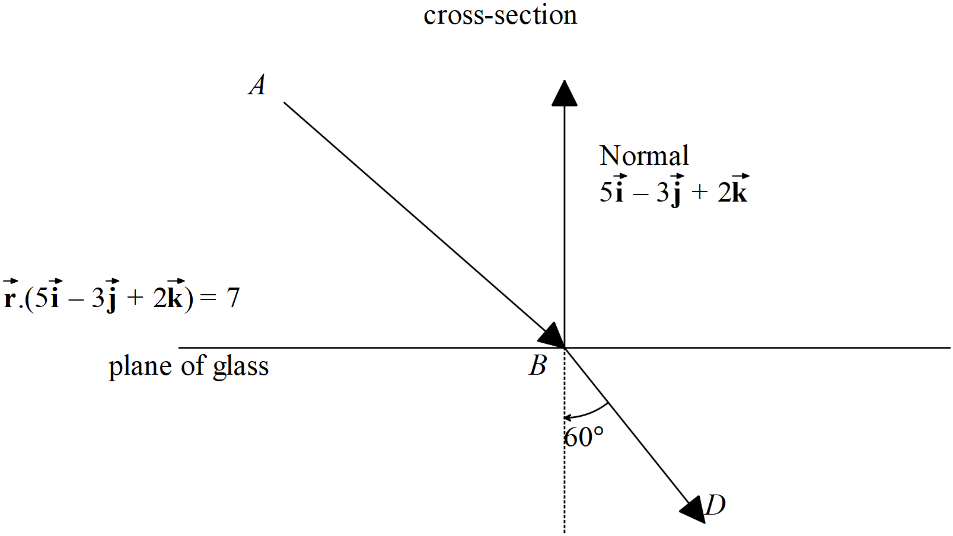

1. Determine the point . (3 marks)

|  |
| --- |
| **Solution** |
|  |
| **Specific behaviours** |
| 🗸 determines vector eqn of line of photon  🗸 sets up linear equation with vector eqn of plane  🗸 solves for point B |

Let  represent a unit vector and be represented as  with 

1. Determine two other independent equations for . (4 marks)

|  |
| --- |
| **Solution** |
| crossP([[7],[-1],[5]],[[5],[-3],[2]])      OR |
| **Specific behaviours** |
| 🗸 uses dot product with BD and normal  🗸 obtains an eqn in terms of a,b&c  🗸 uses cross product with BD  🗸 uses dot product of this cross product with vector in plane to derive second eqn |

Question continued

1. Hence solve for vector  using your CAS calculator (simultaneous) to 2 decimal places.

|  |
| --- |
| **Solution** |
|  |
| **Specific behaviours** |
| 🗸 uses simultaneous mode on CAS with three independent eqns for a.b&c  🗸 solves for at least one set of values  NOTE: Follow through will only occur if correct ideas were used in setting up equations in b above. |

Additional working space

Question number:

Additional working space

Question number: